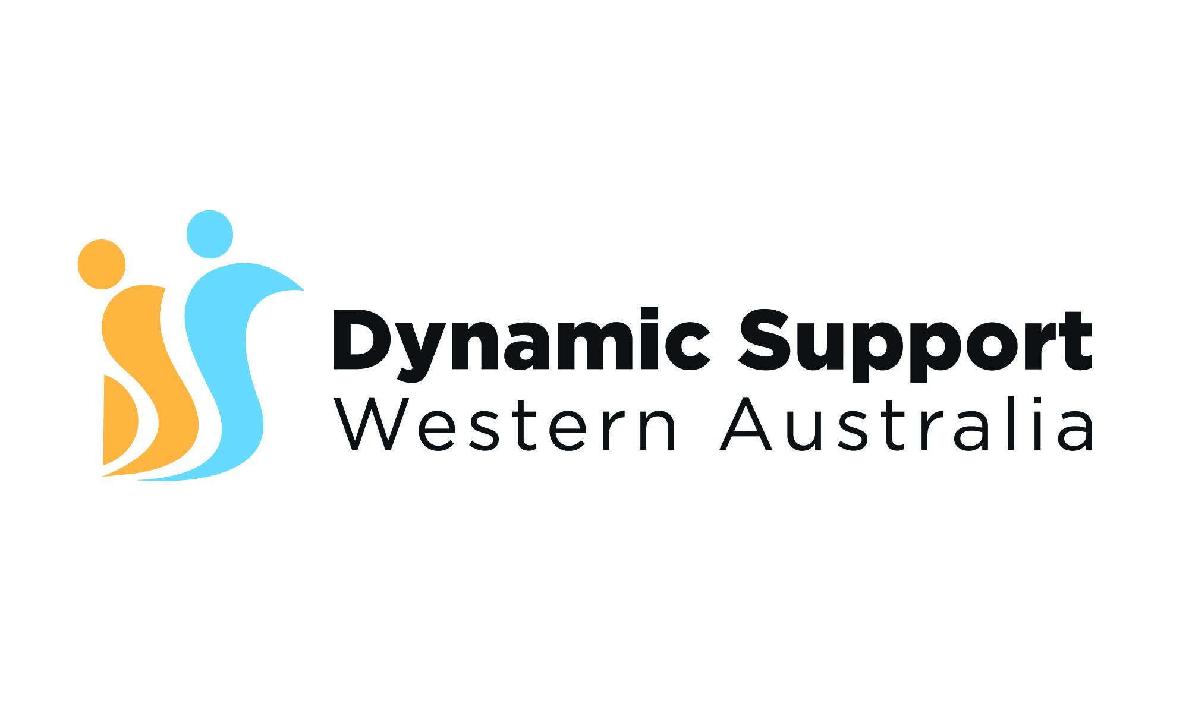**Interview Tips!**

1️⃣ 𝗥𝗲𝘀𝗲𝗮𝗿𝗰𝗵, 𝗥𝗲𝘀𝗲𝗮𝗿𝗰𝗵, 𝗥𝗲𝘀𝗲𝗮𝗿𝗰𝗵: Dive deep into the company's background, culture, values, and recent wins. Tailor your responses to showcase your alignment with their mission.

2️⃣ 𝗣𝗿𝗮𝗰𝘁𝗶𝗰𝗲 𝗠𝗮𝗸𝗲𝘀 𝗣𝗲𝗿𝗳𝗲𝗰𝘁: Fine-tune your answers by practising with a friend, support worker or in front of a mirror. This helps you articulate your thoughts clearly and confidently.

3️⃣ 𝗞𝗻𝗼𝘄 𝗬𝗼𝘂𝗿 𝗦𝘁𝗿𝗲𝗻𝗴𝘁𝗵𝘀: Identify your key strengths and unique selling points. Showcase how they bring value to the role and the organisation.

4️⃣ 𝗕𝗲 𝗦𝗧𝗔𝗥-𝗥𝗲𝗮𝗱𝘆: Structure your answers using the STAR method for behavioural questions. Provide concise yet comprehensive responses showcasing your problem-solving skills.

5️⃣ 𝗤𝘂𝗲𝘀𝘁𝗶𝗼𝗻𝘀 𝗔𝗿𝗲 𝗮 𝗧𝘄𝗼-𝗪𝗮𝘆 𝗦𝘁𝗿𝗲𝗲𝘁: Prepare thoughtful questions about the company, team dynamics, and the role. Demonstrate your genuine interest and assess if it's the right fit for you.

6️⃣ 𝗗𝗿𝗲𝘀𝘀 𝘁𝗵𝗲 𝗣𝗮𝗿𝘁: Align your attire with the company's culture. When you look confident, you'll feel confident and make a positive first impression.

7️⃣ 𝗕𝗼𝗱𝘆 𝗟𝗮𝗻𝗴𝘂𝗮𝗴𝗲 𝗠𝗮𝘁𝘁𝗲𝗿𝘀: Convey confidence and enthusiasm through positive body language – eye contact, a firm handshake, and sitting up straight.

8️⃣ 𝗛𝗶𝗴𝗵𝗹𝗶𝗴𝗵𝘁 𝗬𝗼𝘂𝗿 𝗔𝗰𝗵𝗶𝗲𝘃𝗲𝗺𝗲𝗻𝘁𝘀: Use specific examples to showcase your accomplishments and how you can contribute to the company's success.

9️⃣ 𝗦𝘁𝗮𝘆 𝗖𝗮𝗹𝗺 𝗨𝗻𝗱𝗲𝗿 𝗣𝗿𝗲𝘀𝘀𝘂𝗿𝗲: Take deep breaths, stay composed, and let your true personality shine through.

🔟 𝗦𝗲𝗻𝗱 𝗮 𝗧𝗵𝗮𝗻𝗸-𝗬𝗼𝘂 𝗡𝗼𝘁𝗲: After the interview, express gratitude and reiterate your interest in the role through a personalised thank-you note.